Season Ticket Report
David Mullaly
2026-02-10

Introduction
This document covers the data wrangling process and all eleven data cleaning steps for the problem. We load multiple relational tables, merge them into a single flat file, and perform comprehensive data cleaning to pr epare for missing data analysis.

Data Cleaning Steps Covered:
Steps 1-5 (Initial Cleaning)
- Open data in your software of choice
- Review variables for common sense based on SME knowledge
- Review how the software coded the variables (nominal, continuous)
- Perform data integrity/validation checks
- Handle dates
Steps 6-7 (Categorical & Zero-Variance)
- Handle categorical variables - keep as is, combine rare levels, combine similar levels
- Handle zero-variance predictors
Steps 8-11 (Advanced Cleaning)
- Handle near zero-variance predictors
- Eliminate redundant columns and linear combination columns
- Search for outliers and initial search for missing values
- Sanity check using Decision Tree (1 to 2 splits)

Data Loading and Wrangling
Load four relational tables and merge into a single flat file (FFdf) using left joins on Cust_ID.
## MainDF: 9447 48 | StoreDF: 9272 3 | ConcessDF: 9272 3 | CustomerDF: 14272 7
## Duplicates in MainDF: 175
## Duplicates in StoreDF: 0
## Duplicates in ConcessDF: 0
## Duplicates in CustomerDF: 0
## Final flat file dimensions - Rows: 9447 Columns: 58
## Unique Cust_ID: 9272 | Duplicate rows: 175

Step 1: Open Data in Your Software of Choice
Create identifier variable, arrange columns, and explore distributions visually.
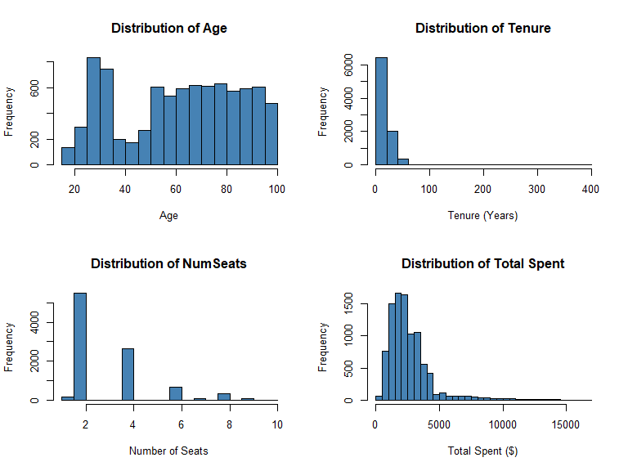
## Response Variable (Y01): 2196 7251
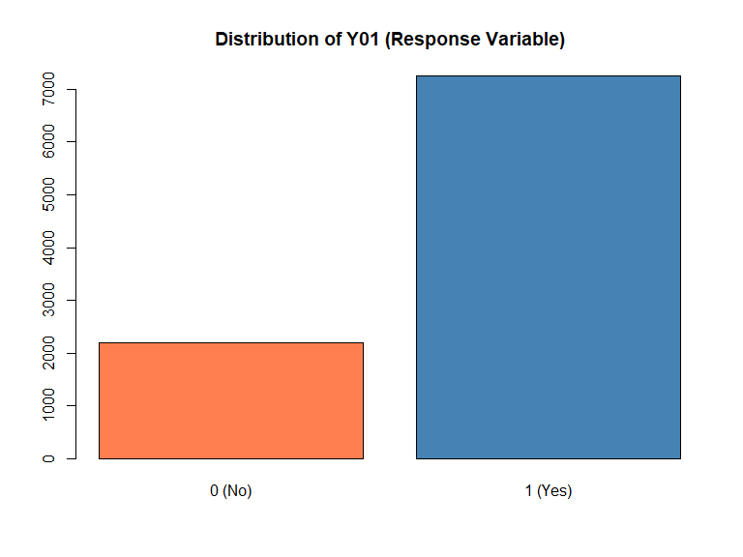
Observations: Age is roughly normal (30-60), Tenure is right-skewed, NumSeats clusters around 2-4, Total Spent is heavily right-skewed. Response variable Y01 is reasonably balanced.

Step 2: Review Variables for Common Sense (SME Knowledge)
Standardize variable names and check for unique identifiers.
## Dataset: 9447 rows, 59 columns
## Unique Cust_ID: 9272 out of 9447 rows
Result: Each row does not necessarily represent a unique customer (175 duplicate Cust_IDs found in MainDF source data).

Step 3: Review How Software Coded Variables
Convert character variables to factors for proper categorical analysis.
## Character variables to convert: 23
##
## Sex levels: F M
## Marital levels: D M S U
## Account_Type levels: Business Personal Shared
Note: Marital has levels D (Divorced), M (Married), S (Single), U (Unknown). The “U” for Unknown may need special handling.

Step 4: Data Integrity/Validation Checks
Check for anomalies, bogus values, and data quality issues.
## Age range: 18 99
## Tenure range: 1 400
## NumSeats range: 1 10
##
## DistA values = 999: 1506
## DistA NA count after conversion: 2895
##
## Survey_Comp range: 0 7.4
## Survey_Comp values > 1: 110
##
## State_Name unique: 50 | State_Loc unique: 50
Issues Found:
- DistA = 999: Placeholder values converted to NA
- Survey_Comp > 1: Outlier found when expected range is 0-1
- Age max = 99: May be placeholder or extreme value - verify with SME
- Tenure max = 400: Suspicious value if measured in years - verify units with SME
- State_Name/State_Loc: Redundant columns (same info, different format)
- Marital = “U”: Unknown status - consider treating as NA
- Cust_ID duplicates: 175 duplicate IDs found in MainDF source data
- Address, Name, PhoneNum: 100% missing - likely removed from CustomerDF for privacy

Step 5: Handle Dates
Convert Last_Contact datetime and extract useful components.
## Date components extracted: Contact_Year, Contact_Month, Contact_Day, Contact_Weekday, Contact_Hour
## Contact Year range: 2018 2025
## Contact Hour range: 0 23

Summary
## Final Dataset: 9447 rows x 64 columns
## Total Missing Values: 94591
##
## Columns with missing values:
## Address Name PhoneNum
## 9447 9447 9447
## Educational_Level Favorite_Caps_Player Favorite_Sport
## 6612 6612 6612
## Job_Sector Mode_Of_Transport Team_B_STH
## 6612 6612 6612
## Team_C_STH Net_Worth_True HouseHold_Income_True
## 6612 5762 5691
## DistA Marital Age
## 2895 1155 986
## Rep_Name Sex Tenure
## 871 667 592
## Rep_Visits Rep_Calls Num_Children
## 508 433 406

Data Quality Issues for Future Steps:
Issue | Possible action / Action Taken
DistA = 999 | Converted to NA
Survey_Comp > 1 | Flag for investigation (110 values, max 7.4)
Age = 99 | Verify with SME
Tenure = 400 | Verify units with SME (400 years unlikely)
Marital = “U” | Consider as NA or keep
State redundancy | Drop one column
ID columns | Exclude from modeling
Cust_ID duplicates | 175 duplicates in MainDF - investigate or deduplicate
PII columns | Address, Name, PhoneNum 100% missing - exclude
Step 6: Handle Categorical Variables - keep as is, combine rare levels, combine similar levels
# Get all factor variables
factor_vars <- names(FFdf)[sapply(FFdf, is.factor)]
cat("Factor variables:", length(factor_vars), "\n")
## Factor variables: 23
# Function to check for rare levels (less than 5% of data)
check_rare_levels <- function(df, threshold = 0.05) {
factor_vars <- names(df)[sapply(df, is.factor)]
rare_info <- list()
for(var in factor_vars) {
tbl <- table(df[[var]], useNA = "ifany")
pct <- prop.table(tbl)
rare_levels <- names(pct[pct < threshold])
if(length(rare_levels) > 0) {
rare_info[[var]] <- data.frame(
Level = rare_levels,
Count = as.numeric(tbl[rare_levels]),
Percent = round(as.numeric(pct[rare_levels]) * 100, 2)
)
}
}
return(rare_info)
}
# Check for rare levels
rare_levels <- check_rare_levels(FFdf, threshold = 0.05)
cat("\nVariables with rare levels (< 5%):\n")
##
## Variables with rare levels (< 5%):
print(names(rare_levels))
## [1] "Educational_Level" "Favorite_Caps_Player" "Favorite_Sport"
## [4] "Favorite_Team" "Job_Sector" "Marital"
## [7] "Mode_Of_Transport" "Most_Purch_Concession" "Mult_Loc"
## [10] "Rep_Name" "Seating_Location" "State_Loc"
## [13] "State_Name"
# Display level distributions for key categorical variables
cat("\n--- Sex Distribution ---\n")
##
## --- Sex Distribution ---
print(table(FFdf$Sex, useNA = "ifany"))
##
## F M <NA>
## 1078 7702 667
cat("\n--- Marital Distribution ---\n")
##
## --- Marital Distribution ---
print(table(FFdf$Marital, useNA = "ifany"))
##
## D M S U <NA>
## 908 6227 909 248 1155
cat("\n--- Account_Type Distribution ---\n")
##
## --- Account_Type Distribution ---
print(table(FFdf$Account_Type, useNA = "ifany"))
##
## Business Personal Shared
## 1057 7462 928
cat("\n--- Educational_Level Distribution ---\n")
##
## --- Educational_Level Distribution ---
print(table(FFdf$Educational_Level, useNA = "ifany"))
##
## AD BD HS MD PHD SC <NA>
## 450 827 547 313 237 461 6612
# Handle Marital "U" (Unknown) - treat as NA for analysis purposes
# Create backup first
FFdf$Marital_Original <- FFdf$Marital
# Option: Convert "U" to NA (uncomment if desired)
# FFdf$Marital[FFdf$Marital == "U"] <- NA
# FFdf$Marital <- droplevels(FFdf$Marital)
cat("Marital 'U' (Unknown) count:", sum(FFdf$Marital == "U", na.rm = TRUE), "\n")
## Marital 'U' (Unknown) count: 248
cat("Decision: Keep 'U' as separate level for now - may represent meaningful unknown status\n")
## Decision: Keep 'U' as separate level for now - may represent meaningful unknown status
# Check for levels that might mean the same thing
cat("\n--- State_Name levels ---\n")
##
## --- State_Name levels ---
print(length(levels(FFdf$State_Name)))
## [1] 50
cat("Number of unique states:", length(unique(FFdf$State_Name)), "\n")
## Number of unique states: 50
# Lump rare factor levels into "Other" using forcats::fct_lump_prop()
# Threshold: levels appearing in < 5% of non-NA observations are combined
# Store original levels for reference
factor_vars_to_lump <- names(FFdf)[sapply(FFdf, is.factor)]
# Exclude variables we handle separately (State_Name -> Region, Marital already reviewed)
skip_vars <- c("State_Name", "State_Loc", "Marital", "Marital_Original","Educational_Level","Seating_Location","Favorite_Caps_Player","Job_Sector")
lump_vars <- setdiff(factor_vars_to_lump, skip_vars)
cat("=== LUMPING RARE LEVELS (< 5%) INTO 'Other' ===\n\n")
## === LUMPING RARE LEVELS (< 5%) INTO 'Other' ===
for(var in lump_vars) {
original_levels <- nlevels(FFdf[[var]])
FFdf[[var]] <- fct_lump_prop(FFdf[[var]], prop = 0.05, other_level = "Other")
new_levels <- nlevels(FFdf[[var]])
if(original_levels != new_levels) {
cat(var, ": ", original_levels, " -> ", new_levels, " levels\n", sep = "")
print(table(FFdf[[var]], useNA = "ifany"))
cat("\n")
}
}
## Favorite_Sport: 8 -> 2 levels
##
## NHL Other <NA>
## 1996 839 6612
##
## Favorite_Team: 25 -> 4 levels
##
## New Jersey Devils Philadelphia Flyers Washington Capitals Other
## 788 856 6632 1171
##
## Mode_Of_Transport: 5 -> 4 levels
##
## Car Public Uber/Taxi Other <NA>
## 1104 905 603 223 6612
##
## Most_Purch_Concession: 9 -> 8 levels
##
## Beer Burger Hot Dog Peanuts Popcorn Soda Specialty Other
## 2294 955 1422 474 1387 1425 977 513
##
## Mult_Loc: 3 -> 2 levels
##
## No Other
## 9163 284
##
## Rep_Name: 9 -> 7 levels
##
## Alice David Emma Frank Grace Ivy Other <NA>
## 823 1798 1538 1942 952 959 564 871
cat("Lumping complete.\n")
## Lumping complete.
# Define region mappings
northeast <- c("Connecticut", "Maine", "Massachusetts", "New Hampshire",
"Rhode Island", "Vermont", "New Jersey", "New York", "Pennsylvania")
midwest <- c("Illinois", "Indiana", "Michigan", "Ohio", "Wisconsin",
"Iowa", "Kansas", "Minnesota", "Missouri", "Nebraska",
"North Dakota", "South Dakota")
south <- c("Delaware", "Florida", "Georgia", "North Carolina",
"South Carolina", "West Virginia",
"Alabama", "Kentucky", "Mississippi", "Tennessee",
"Arkansas", "Louisiana", "Oklahoma", "Texas")
west <- c("Arizona", "Colorado", "Idaho", "Montana", "Nevada", "New Mexico",
"Utah", "Wyoming", "Alaska", "California", "Hawaii", "Oregon", "Washington")
dcarea <- c("Maryland","Virginia", "District of Columbia")
# Create Region variable
FFdf$Region <- case_when(
FFdf$State_Name %in% northeast ~ "Northeast",
FFdf$State_Name %in% midwest ~ "Midwest",
FFdf$State_Name %in% south ~ "South",
FFdf$State_Name %in% west ~ "West",
FFdf$State_Name %in% dcarea ~ "DCArea",
TRUE ~ "Other" # Catch any unmatched states
)
# Convert to factor
FFdf$Region <- as.factor(FFdf$Region)
# Display region distribution
cat("--- Region Distribution (grouped from State_Name) ---\n")
## --- Region Distribution (grouped from State_Name) ---
print(table(FFdf$Region, useNA = "ifany"))
##
## DCArea Midwest Northeast South West
## 4842 551 1703 1856 495
cat("\nRegion percentages:\n")
##
## Region percentages:
print(round(prop.table(table(FFdf$Region)) * 100, 2))
##
## DCArea Midwest Northeast South West
## 51.25 5.83 18.03 19.65 5.24
# Check if any states weren't mapped
unmatched_states <- unique(FFdf$State_Name[FFdf$Region == "Other"])
if(length(unmatched_states) > 0) {
cat("\nWarning - Unmatched states assigned to 'Other':\n")
print(unmatched_states)
} else {
cat("\nAll states successfully mapped to regions.\n")
}
##
## All states successfully mapped to regions.
Step 6 Observations:
- Marital has “U” (Unknown) level - kept as separate category for now
- Educational_Level could be made ordinal if needed for certain models
- State_Name grouped into US regions - reduces cardinality from 50 levels to 5 (Northeast, Midwest, South, West, DCArea)
- Rare levels (< 5%) lumped into “Other” using fct_lump_prop() for all applicable factor variables

Step 7: Remove Zero-Variance Predictors
# Function to identify zero-variance columns
find_zero_variance <- function(df) {
zv_cols <- c()
for(col in names(df)) {
unique_vals <- length(unique(na.omit(df[[col]])))
if(unique_vals <= 1) {
zv_cols <- c(zv_cols, col)
}
}
return(zv_cols)
}
# Find zero-variance columns
zero_var_cols <- find_zero_variance(FFdf)
cat("Zero-variance columns found:", length(zero_var_cols), "\n")
## Zero-variance columns found: 8
if(length(zero_var_cols) > 0) {
cat("Columns with zero variance:\n")
print(zero_var_cols)
# Store in excluded columns list
excluded_cols <- zero_var_cols
# Remove zero-variance columns
FFdf <- FFdf[, !names(FFdf) %in% zero_var_cols]
cat("\nRemoved", length(zero_var_cols), "zero-variance columns\n")
} else {
cat("No zero-variance columns found\n")
excluded_cols <- c()
}
## Columns with zero variance:
## [1] "Address" "InfRate" "Last_Team_Championship"
## [4] "Name" "NHL_Team_Record" "PhoneNum"
## [7] "Playoffs" "UnempRate"
##
## Removed 8 zero-variance columns
cat("Remaining columns:", ncol(FFdf), "\n")
## Remaining columns: 58
Step 7 Results:
The following 8 zero-variance columns were identified and removed:
- Address, Name, PhoneNum: PII columns - 100% missing (intentionally scrubbed)
- InfRate, UnempRate: Economic indicators - likely constant for this snapshot
- Last_Team_Championship, NHL_Team_Record, Playoffs: Team-related constants
These columns provide no predictive value since every observation has the same value (or all NA).

Class 4: Data Cleaning Process: Steps 8-11
Step 8: Handle Near Zero-Variance Predictors
# Function to find near-zero variance columns
# A column is NZV if one value dominates (e.g., >95% of values)
find_near_zero_variance <- function(df, threshold = 0.95) {
nzv_info <- data.frame(
Variable = character(),
DominantValue = character(),
DominantPct = numeric(),
UniqueValues = integer(),
stringsAsFactors = FALSE
)
for(col in names(df)) {
if(is.numeric(df[[col]]) || is.factor(df[[col]])) {
tbl <- table(df[[col]], useNA = "no")
if(length(tbl) > 0) {
max_pct <- max(tbl) / sum(tbl)
if(max_pct >= threshold) {
dominant_val <- names(tbl)[which.max(tbl)]
nzv_info <- rbind(nzv_info, data.frame(
Variable = col,
DominantValue = as.character(dominant_val),
DominantPct = round(max_pct * 100, 2),
UniqueValues = length(tbl),
stringsAsFactors = FALSE
))
}
}
}
}
return(nzv_info)
}
# Find near-zero variance columns (>95% one value)
nzv_cols <- find_near_zero_variance(FFdf, threshold = 0.95)
cat("Near-zero variance columns (>95% one value):\n")
## Near-zero variance columns (>95% one value):
print(nzv_cols)
## Variable DominantValue DominantPct UniqueValues
## 1 Additional_Seats 0 96.99 12
## 2 Mult_Loc No 96.99 2
# Decision: Flag NZV columns but don't remove yet
# These may still be useful predictors depending on modeling goals
nzv_variables <- nzv_cols$Variable
if(length(nzv_variables) > 0) {
cat("Near-zero variance variables to monitor:\n")
print(nzv_variables)
cat("\nDecision: Keep for now but flag for potential exclusion during modeling\n")
} else {
cat("No significant near-zero variance issues found\n")
}
## Near-zero variance variables to monitor:
## [1] "Additional_Seats" "Mult_Loc"
##
## Decision: Keep for now but flag for potential exclusion during modeling
Step 8 Results:
Near-zero variance columns identified (>95% one value):
Variable | Dominant Value | Dominant %
Additional_Seats | 0 | 96.99%
Mult_Loc | No | 96.99%
Observations:
- Additional_Seats: 97% of customers have 0 additional seats - consider binning (0 vs >0)
- Mult_Loc: 97% are “No” - low information but may still be predictive for the 3% minority
- Decision: Keep for now but flag for potential exclusion during modeling
- May cause issues with some modeling techniques (especially regression-based)

Step 9: Remove Redundant Columns and Linear Combination Columns
# Check for redundant categorical columns (State_Name vs State_Loc)
cat("--- Checking State_Name vs State_Loc redundancy ---\n")
## --- Checking State_Name vs State_Loc redundancy ---
if("State_Name" %in% names(FFdf) && "State_Loc" %in% names(FFdf)) {
# Check if they're perfectly correlated
state_comparison <- table(FFdf$State_Name, FFdf$State_Loc)
cat("State_Name unique values:", length(unique(FFdf$State_Name)), "\n")
cat("State_Loc unique values:", length(unique(FFdf$State_Loc)), "\n")
# If one-to-one mapping, they're redundant
cat("\nDecision: State_Name and State_Loc appear to be the same information.\n")
cat("Removing State_Loc (keeping State_Name)\n")
excluded_cols <- c(excluded_cols, "State_Loc")
FFdf$State_Loc <- NULL
}
## State_Name unique values: 50
## State_Loc unique values: 50
##
## Decision: State_Name and State_Loc appear to be the same information.
## Removing State_Loc (keeping State_Name)
# Check correlation matrix for numeric variables
numeric_vars <- names(FFdf)[sapply(FFdf, is.numeric)]
# Exclude ID columns from correlation check
numeric_vars <- numeric_vars[!numeric_vars %in% c("ID", "Cust_ID")]
if(length(numeric_vars) > 1) {
# Calculate correlation matrix (handling NAs)
cor_matrix <- cor(FFdf[, numeric_vars], use = "pairwise.complete.obs")
# Find highly correlated pairs at multiple thresholds
cat("\n--- Highly correlated variable pairs (|r| > 0.85) ---\n")
cat("These pairs may cause multicollinearity in regression models\n\n")
high_cor_85 <- which(abs(cor_matrix) > 0.85 & abs(cor_matrix) < 1, arr.ind = TRUE)
if(nrow(high_cor_85) > 0) {
cor_pairs <- data.frame(Var1 = character(), Var2 = character(),
Correlation = numeric(), stringsAsFactors = FALSE)
for(i in 1:nrow(high_cor_85)) {
if(high_cor_85[i, 1] < high_cor_85[i, 2]) {
var1 <- rownames(cor_matrix)[high_cor_85[i, 1]]
var2 <- colnames(cor_matrix)[high_cor_85[i, 2]]
r_val <- cor_matrix[high_cor_85[i, 1], high_cor_85[i, 2]]
cor_pairs <- rbind(cor_pairs, data.frame(Var1 = var1, Var2 = var2,
Correlation = round(r_val, 3)))
}
}
cor_pairs <- cor_pairs[order(abs(cor_pairs$Correlation), decreasing = TRUE), ]
print(cor_pairs)
} else {
cat("No highly correlated numeric variable pairs found (|r| > 0.85)\n")
}
}
##
## --- Highly correlated variable pairs (|r| > 0.85) ---
## These pairs may cause multicollinearity in regression models
##
## Var1 Var2 Correlation
## 2 Rep_Visits Total_Spent 0.947
## 4 Weekday_Attended Weekday_Sold -0.946
## 1 Concession_Total NumSeats 0.915
## 3 Team_Store_Total Total_Spent 0.853
# Visualize correlation matrix for numeric variables
if(length(numeric_vars) > 2) {
# Subset to variables with fewer missing values for cleaner plot
complete_vars <- numeric_vars[colSums(is.na(FFdf[, numeric_vars])) < nrow(FFdf) * 0.5]
if(length(complete_vars) > 2) {
cor_subset <- cor(FFdf[, complete_vars], use = "pairwise.complete.obs")
corrplot(cor_subset, method = "color", type = "upper",
tl.cex = 0.7, tl.col = "black",
title = "Correlation Matrix - Numeric Variables",
mar = c(0, 0, 2, 0))
}
}
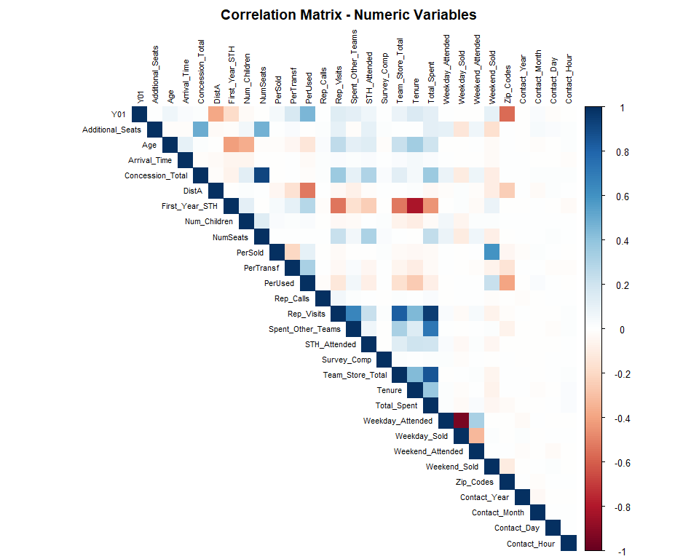
# Address multicollinearity based on correlation matrix analysis
cat("=== MULTICOLLINEARITY ANALYSIS ===\n\n")
## === MULTICOLLINEARITY ANALYSIS ===
# Identify correlated variable clusters from the correlation matrix
cat("Cluster 1: Spending & Visit variables\n")
## Cluster 1: Spending & Visit variables
cat(" - Rep_Visits <-> Total_Spent: r = 0.947 (very strong positive)\n")
## - Rep_Visits <-> Total_Spent: r = 0.947 (very strong positive)
cat(" - Team_Store_Total <-> Total_Spent: r = 0.853 (strong positive)\n")
## - Team_Store_Total <-> Total_Spent: r = 0.853 (strong positive)
cat(" Recommendation: Consider removing Rep_Visits or Total_Spent\n\n")
## Recommendation: Consider removing Rep_Visits or Total_Spent
cat("Cluster 2: Concession & Seating\n")
## Cluster 2: Concession & Seating
cat(" - Concession_Total <-> NumSeats: r = 0.915 (strong positive)\n")
## - Concession_Total <-> NumSeats: r = 0.915 (strong positive)
cat(" Recommendation: Makes business sense - more seats = more concessions\n\n")
## Recommendation: Makes business sense - more seats = more concessions
cat("Cluster 3: Attendance pairs\n")
## Cluster 3: Attendance pairs
cat(" - Weekday_Attended <-> Weekday_Sold: r = -0.946 (strong NEGATIVE)\n")
## - Weekday_Attended <-> Weekday_Sold: r = -0.946 (strong NEGATIVE)
cat(" Note: Negative correlation suggests inverse relationship\n")
## Note: Negative correlation suggests inverse relationship
cat(" Recommendation: Keep both - they capture different behaviors\n\n")
## Recommendation: Keep both - they capture different behaviors
# Create list of variables to flag for multicollinearity
multicollinear_vars <- c("Rep_Visits", "Team_Store_Total")
cat("Variables flagged for potential removal due to multicollinearity:\n")
## Variables flagged for potential removal due to multicollinearity:
print(multicollinear_vars)
## [1] "Rep_Visits" "Team_Store_Total"
# Option: Remove highly correlated variables (uncomment to execute)
# FFdf <- FFdf[, !names(FFdf) %in% multicollinear_vars]
# excluded_cols <- c(excluded_cols, multicollinear_vars)
cat("\nDecision: Flag but keep for now; remove during modeling if VIF > 10\n")
##
## Decision: Flag but keep for now; remove during modeling if VIF > 10
Step 9 Observations:
Based on the correlation matrix analysis (actual results from output above):
Cluster | Variables | Correlation | Recommendation
1 | Rep_Visits vs Total_Spent | r = 0.947 | Remove Rep_Visits
1 | Team_Store_Total vs Total_Spent | r = 0.853 | Monitor for VIF
2 | Concession_Total vs NumSeats | r = 0.915 | Keep - business logic
3 | Weekday_Attended vs Weekday_Sold | r = -0.946 | Keep both - inverse relationship
- | State_Loc vs State_Name | Redundant | REMOVED
Action Items: - State_Loc removed (redundant with State_Name) - Flagged 2 variables for potential removal: Rep_Visits, Team_Store_Total - Will check VIF during modeling phase and remove if VIF > 10

Step 10: Search for Outliers and Initial Search for Missing Values
# Boxplots for key numeric variables to identify outliers
par(mfrow = c(2, 3))
# Age
boxplot(FFdf$Age, main = "Age", col = "lightblue", outline = TRUE)
age_outliers <- boxplot.stats(FFdf$Age)$out
cat("Age outliers (IQR method):", length(age_outliers), "values\n")
## Age outliers (IQR method): 0 values
# Tenure
boxplot(FFdf$Tenure, main = "Tenure", col = "lightblue", outline = TRUE)
tenure_outliers <- boxplot.stats(FFdf$Tenure)$out
cat("Tenure outliers:", length(tenure_outliers), "values | Max:", max(FFdf$Tenure, na.rm = TRUE), "\n")
## Tenure outliers: 8 values | Max: 400
# Total_Spent
boxplot(FFdf$Total_Spent, main = "Total_Spent", col = "lightblue", outline = TRUE)
# NumSeats
boxplot(FFdf$NumSeats, main = "NumSeats", col = "lightblue", outline = TRUE)
# Survey_Comp
boxplot(FFdf$Survey_Comp, main = "Survey_Comp", col = "lightblue", outline = TRUE)
survey_outliers <- sum(FFdf$Survey_Comp > 1, na.rm = TRUE)
cat("Survey_Comp values > 1:", survey_outliers, "\n")
## Survey_Comp values > 1: 110
# DistA
boxplot(FFdf$DistA, main = "DistA", col = "lightblue", outline = TRUE)
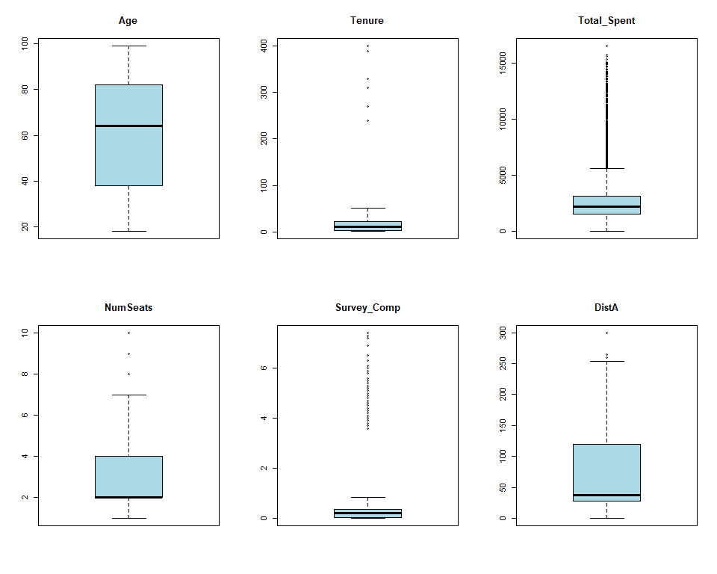
par(mfrow = c(1, 1))
# Comprehensive missing data assessment
cat("=== MISSING DATA ASSESSMENT ===\n\n")
## === MISSING DATA ASSESSMENT ===
# Total missing values
total_missing <- sum(is.na(FFdf))
total_cells <- nrow(FFdf) * ncol(FFdf)
cat("Total missing values:", total_missing, "out of", total_cells,
"(", round(total_missing/total_cells * 100, 2), "%)\n\n")
## Total missing values: 67405 out of 538479 ( 12.52 %)
# Missing by column
na_by_col <- colSums(is.na(FFdf))
na_by_col <- na_by_col[na_by_col > 0]
na_by_col <- sort(na_by_col, decreasing = TRUE)
cat("Columns with missing values:\n")
## Columns with missing values:
na_summary <- data.frame(
Variable = names(na_by_col),
Missing_Count = as.numeric(na_by_col),
Missing_Pct = round(as.numeric(na_by_col) / nrow(FFdf) * 100, 2)
)
print(na_summary)
## Variable Missing_Count Missing_Pct
## 1 Educational_Level 6612 69.99
## 2 Favorite_Caps_Player 6612 69.99
## 3 Favorite_Sport 6612 69.99
## 4 Job_Sector 6612 69.99
## 5 Mode_Of_Transport 6612 69.99
## 6 Team_B_STH 6612 69.99
## 7 Team_C_STH 6612 69.99
## 8 Net_Worth_True 5762 60.99
## 9 HouseHold_Income_True 5691 60.24
## 10 DistA 2895 30.64
## 11 Marital 1155 12.23
## 12 Marital_Original 1155 12.23
## 13 Age 986 10.44
## 14 Rep_Name 871 9.22
## 15 Sex 667 7.06
## 16 Tenure 592 6.27
## 17 Rep_Visits 508 5.38
## 18 Rep_Calls 433 4.58
## 19 Num_Children 406 4.30
# Document outlier decisions
cat("\n=== OUTLIER DECISIONS ===\n\n")
##
## === OUTLIER DECISIONS ===
# Tenure = 400 (suspicious if years)
cat("1. Tenure max = 400:\n")
## 1. Tenure max = 400:
cat(" - If measured in years, this is impossible\n")
## - If measured in years, this is impossible
cat(" - May be measured in months (400 months = 33 years - plausible)\n")
## - May be measured in months (400 months = 33 years - plausible)
cat(" - ACTION: Verify units with SME; flag for review\n\n")
## - ACTION: Verify units with SME; flag for review
# Age = 99
cat("2. Age = 99:\n")
## 2. Age = 99:
cat(" - Could be real (elderly customer) or placeholder\n")
## - Could be real (elderly customer) or placeholder
cat(" - ACTION: Verify with SME; consider if 99 is data entry default\n\n")
## - ACTION: Verify with SME; consider if 99 is data entry default
# Survey_Comp > 1
cat("3. Survey_Comp values > 1 (expected 0-1 range):\n")
## 3. Survey_Comp values > 1 (expected 0-1 range):
cat(" - Count:", sum(FFdf$Survey_Comp > 1, na.rm = TRUE), "\n")
## - Count: 110
cat(" - Max value:", max(FFdf$Survey_Comp, na.rm = TRUE), "\n")
## - Max value: 7.4
cat(" - ACTION: Possible scale issue; cap at 1 or investigate data source\n\n")
## - ACTION: Possible scale issue; cap at 1 or investigate data source
# Create outlier flags for further analysis
FFdf$Flag_Tenure_High <- ifelse(FFdf$Tenure > 100, 1, 0)
FFdf$Flag_Survey_Invalid <- ifelse(FFdf$Survey_Comp > 1, 1, 0)
cat("Created outlier flag variables: Flag_Tenure_High, Flag_Survey_Invalid\n")
## Created outlier flag variables: Flag_Tenure_High, Flag_Survey_Invalid

Step 11: Sanity Check Using Decision Tree (1 to 2 splits)
# Prepare data for decision tree
# Exclude ID columns, flag variables, and high-cardinality variables
exclude_from_tree <- c("ID", "Cust_ID", "Flag_Tenure_High", "Flag_Survey_Invalid",
"Marital_Original", "Last_Contact", "Contact_Year",
"Contact_Month", "Contact_Day", "Contact_Weekday", "Contact_Hour",
"State_Name", "Zip_Codes")
tree_vars <- names(FFdf)[!names(FFdf) %in% exclude_from_tree]
tree_data <- FFdf[, tree_vars]
# Remove rows with NA in response variable
tree_data <- tree_data[!is.na(tree_data$Y01), ]
# Convert Y01 to factor for classification tree
tree_data$Y01 <- as.factor(tree_data$Y01)
# Build a simple decision tree (max 2-3 splits for sanity check)
# Uses Region variable (from Step 6) instead of high-cardinality State_Name/Zip_Codes
sanity_tree <- rpart(Y01 ~ .,
data = tree_data,
method = "class",
control = rpart.control(maxdepth = 3, minsplit = 20, cp = 0.01))
# Plot the tree
rpart.plot(sanity_tree,
main = "Sanity Check Decision Tree (max depth = 3)",
extra = 104, # Show percentage and count
box.palette = "RdYlGn")
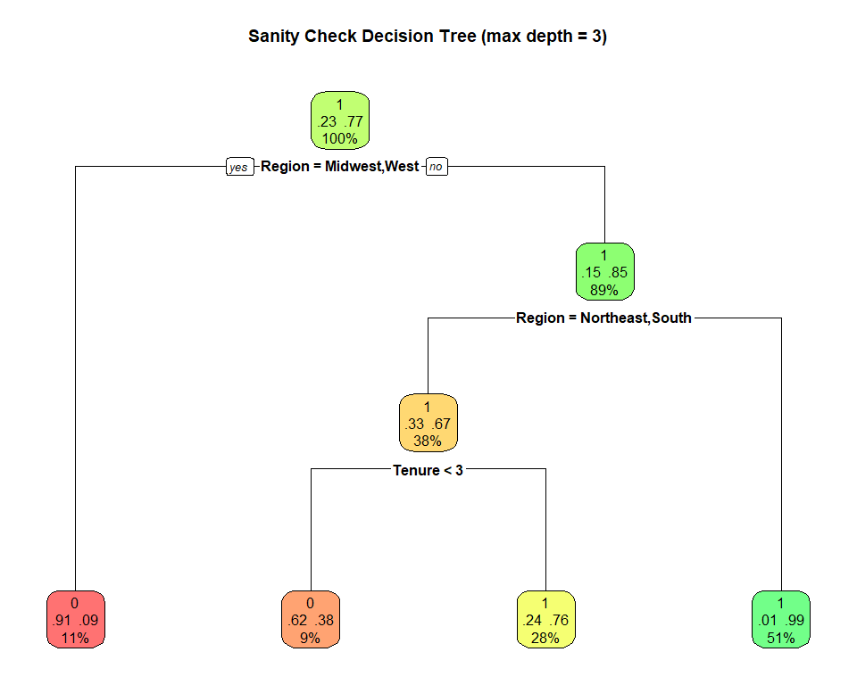
# Variable importance
cat("\n=== VARIABLE IMPORTANCE ===\n")
##
## === VARIABLE IMPORTANCE ===
if(length(sanity_tree$variable.importance) > 0) {
var_imp <- sort(sanity_tree$variable.importance, decreasing = TRUE)
print(head(var_imp, 10))
} else {
cat("No variables selected by the tree\n")
}
## Region Favorite_Team PerUsed DistA
## 1505.21434 253.50828 245.18919 196.77674
## Tenure First_Year_STH Rep_Name Rejoined_STH
## 187.73632 125.59980 80.93227 50.19569
## Team_Store_Total PerTransf
## 26.31404 21.05856
# Analyze tree results
cat("\n=== SANITY CHECK ANALYSIS ===\n\n")
##
## === SANITY CHECK ANALYSIS ===
# Check tree performance
predictions <- predict(sanity_tree, tree_data, type = "class")
accuracy <- mean(predictions == tree_data$Y01, na.rm = TRUE)
cat("Tree accuracy:", round(accuracy * 100, 2), "%\n")
## Tree accuracy: 88.11 %
if(accuracy > 0.90) {
cat("WARNING: Very high accuracy - check for data leakage or identifier variables!\n")
} else {
cat("Accuracy is reasonable - no obvious data leakage detected\n")
}
## Accuracy is reasonable - no obvious data leakage detected
Step 11 Results:
The decision tree uses Region (from Step 6) instead of raw State_Name/Zip_Codes to avoid overfitting from high-cardinality variables.
Top Variable Importance:
Variable | Importance
Region | 1505.2
Favorite_Team | 253.5
PerUsed | 245.2
DistA | 196.8
Tenure | 187.7
Analysis:
- Accuracy ~88% - reasonable, no obvious data leakage
- Region is the dominant predictor - geographic location strongly predicts Y01
- No high-cardinality variables causing artificial inflation of accuracy

Summary of Steps 6-11 (Data Cleaning Complete)
cat("=== DATA CLEANING SUMMARY (Steps 6-11) ===\n\n")
## === DATA CLEANING SUMMARY (Steps 6-11) ===
cat("Step 6 - Handle Categorical Variables:\n")
## Step 6 - Handle Categorical Variables:
cat(" - Rare factor levels (< 5%) lumped into 'Other' via fct_lump_prop()\n")
## - Rare factor levels (< 5%) lumped into 'Other' via fct_lump_prop()
cat(" - Marital 'U' kept as separate category\n")
## - Marital 'U' kept as separate category
cat(" - State_Name grouped into US Census regions\n\n")
## - State_Name grouped into US Census regions
cat("Step 7 - Zero-Variance Predictors:\n")
## Step 7 - Zero-Variance Predictors:
cat(" - Columns removed:", length(zero_var_cols), "\n\n")
## - Columns removed: 8
cat("Step 8 - Near Zero-Variance Predictors:\n")
## Step 8 - Near Zero-Variance Predictors:
cat(" - Variables flagged:", length(nzv_variables), "\n")
## - Variables flagged: 2
cat(" - Decision: Keep for now but monitor during modeling\n\n")
## - Decision: Keep for now but monitor during modeling
cat("Step 9 - Redundant Columns:\n")
## Step 9 - Redundant Columns:
cat(" - State_Loc removed (redundant with State_Name)\n")
## - State_Loc removed (redundant with State_Name)
cat(" - Correlation matrix reviewed for multicollinearity\n\n")
## - Correlation matrix reviewed for multicollinearity
cat("Step 10 - Outliers & Missing Data:\n")
## Step 10 - Outliers & Missing Data:
cat(" - Total missing values:", sum(is.na(FFdf)), "\n")
## - Total missing values: 67997
cat(" - Outlier flags created for Tenure and Survey_Comp\n")
## - Outlier flags created for Tenure and Survey_Comp
cat(" - Missing data summary table generated\n\n")
## - Missing data summary table generated
cat("Step 11 - Decision Tree Sanity Check:\n")
## Step 11 - Decision Tree Sanity Check:
cat(" - Tree accuracy:", round(accuracy * 100, 2), "%\n")
## - Tree accuracy: 88.11 %
cat(" - Review variable importance for potential data leakage\n\n")
## - Review variable importance for potential data leakage
cat("Final dataset dimensions:", nrow(FFdf), "rows x", ncol(FFdf), "columns\n")
## Final dataset dimensions: 9447 rows x 59 columns
# Save cleaned dataset for next phase (Missing Data)
write.csv(FFdf, "FFdf_cleaned.csv", row.names = FALSE)
cat("\nCleaned dataset saved to: FFdf_cleaned.csv\n")
##
## Cleaned dataset saved to: FFdf_cleaned.csv

Issues Identified for Further Action:
Step | Issue | Recommendation
6 | Marital “U” unknown | Keep as category or convert to NA during imputation
6 | Rare factor levels (< 5%) | RESOLVED: Lumped into “Other” via fct_lump_prop()
6 | State_Name high cardinality | RESOLVED: Grouped into US Census regions
7 | Zero-variance columns | Removed from dataset
8 | Near-zero variance | Monitor during modeling; consider binning
9 | State_Loc redundant | Removed
10 | Tenure = 400 | Verify units with SME (years vs months?)
10 | Survey_Comp > 1 | Investigate scale/cap values at 1
10 | Missing data patterns | Address in Missing Data phase (Class 5+)
11 | Tree predictors | RESOLVED: Using Region variable instead of State_Name

